**Year 12 Physics EVALUATION – Friction 2022**

**Research**

**Assessment type:** Science inquiry – Evaluation

**Conditions**

* The task consists of a research period followed by an in-class validation under test conditions
* Time allowed for research: 2 weeks
* The mark awarded for the task will come entirely from the in-class validation to be held at the end of the research period
* All research material (hand-written, printed or photo-copied) may be used during the validation
* Research material will not be required to be submitted as part of the assessment
* The Year 12 Physics Data and Formula sheet may be used during the validation
* Scientific calculator permitted during validation

**Task weighting**

7.5% of the school mark for this pair of units

Investigate the following aspects of Friction:

* Static friction
* Kinetic (sliding, dynamic) friction
* Coefficient of friction
* Calculations of energy and force involving friction

In addition to finding your own resources, you are invited to study the following:

<http://dev.physicslab.org/Document.aspx?doctype=3&filename=Dynamics_FrictionProperties.xml>

<http://www.engineeringtoolbox.com/friction-coefficients-d_778.html>

(Note: The first calculation example in this site, about a wooden crate, gives the force in pounds (lb). This can be converted to newtons by multiplying by 0.4536 to give kilograms, then by 9.8 to give newtons.)

<http://hyperphysics.phy-astr.gsu.edu/hbase/frict.html>

**Year 12 Physics EVALUATION – Friction 2022**

**Validation**

NAME:

*Total Marks: 34 Time Allowed: 45 minutes*

(Formula sheet, research notes and scientific calculator permitted)

**Question 1 (4 marks)**

The following graph shows the friction on an object (that is initially stationary) as the applied horizontal force on the object changes:

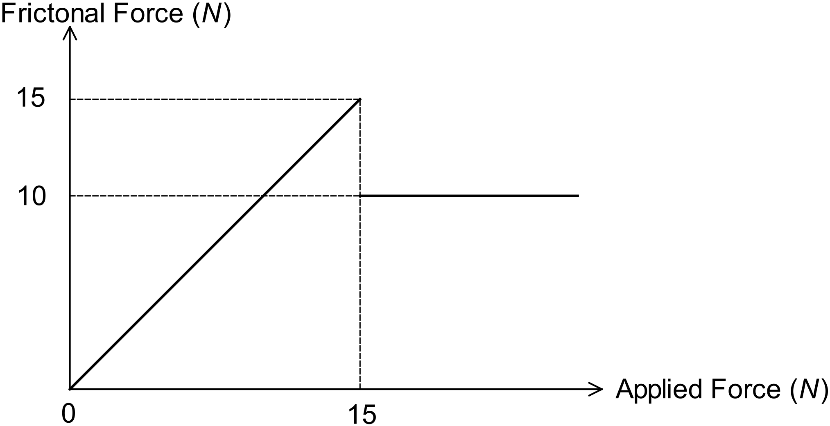

1. Circle the part of the graph that corresponds to the object being stationary and label it (a). [1]
2. Circle the part of the graph that corresponds to the object moving and label it (b).

[1]

1. Start the value of the force of friction on the object when it is moving. [1]
2. State the value of the force needed to make the object move. [1]

**Question 2 (16 marks)**

Max is attempting to push a heavy box along a rough surface.



1. Explain why Max’s task is made easier if his friend Minnie applies an upward force to the box. [2]

Max applies a constant force of 180.0 N and finds that the box initially accelerates at 0.144 ms-2. The box has a mass of 25.0 kg and Minnie is no longer assisting him.

1. Find the coefficient of static friction that applies in this case. [5]
2. Assuming that the coefficient of dynamic friction is 80.0% of the coefficient of static friction, determine the box’s acceleration as it continues to move. [5]
3. If Max lets go of the box when its speed is 2.80 ms-1, how far will it slide before coming to rest? [4]

**Question 3 (6 marks)**

A certain surface has a coefficient of static friction of 0.640 and a coefficient of dynamic friction of 0.480.

1. Calculate the least initial force required to move an object of mass 2.30 kg on the surface. [2]
2. Calculate the minimum force required to sustain the movement of the object in part (a). [2]

Assume the object in part (a) is moving.

1. What will happen to the object if the force now applied is less than the value calculated in part (b)? [1]
2. What will happen to the object if the force now applied is more than the value calculated in part (b)? [1]

**Question 4 (8 marks)**

Ben places a brick on an inclined plank of wood. The coefficient of static friction in this situation is *µ*.

Let *m* = the mass of the brick,

*θ* = the angle of the plane to the horizontal,

and *g* = the acceleration due to gravity.

1. In terms of *µ*, *m*, *g* and *θ*, determine
   1. the normal reaction force of the plank on the brick,
   2. the force of static friction on the brick,
   3. the brick’s weight component down the plane. [5]
2. Hence show that, if the brick is not to slide down the plane, the maximum value of *θ* is given by tan *θ* = *µ*. [3]

*- End of Questions -*